BugBuddy: A Human-Centered Dashboard for Predicting Bug-Prone Functions in Student Code

Natalie Lopez
Human Computer Interaction
Full Sail University
Winter Park, FL, USA
Nlopez5@student.fullsail.edu

Abstract—BugBuddy is a human-centered software analysis application designed to help instructors identify bug-prone functions in student code repositories before manual review becomes unmanageable. The system focuses on function-level prediction rather than file-level prediction, so that resulting feedback is specific, interpretable, and aligned with instructional workflows [1], [2]. In its current implementation, BugBuddy analyzes uploaded code, extracts function-level metrics, estimates bug risk, and presents the result through a web-based dashboard that ranks functions, visualizes key metrics, and explains each prediction in plain language [3], [4].
The project combines static code analysis, machine learning, and interaction design. Static metrics such as non-comment lines of code, cyclomatic complexity, parameter count, and related function-level attributes are used as predictors for bug-proneness, while the interface emphasizes clarity, ranked outputs, and explanation support for instructors. This design aligns with defect-prediction research showing that source-code metrics remain useful features for machine-learning models and that method-level prediction provides more actionable granularity than file-level prediction [1], [2]. The implemented prototype demonstrates an end-to-end workflow consisting of metric extraction, model training, prediction, and browser-based presentation. This paper describes the application, the programming language and toolchain, the algorithms and evaluation metrics, and the rationale for the human-computer interaction behind the dashboard design [3], [5].

Keywords— software defect prediction, method-level bug prediction, static code metrics, Random Forest, educational software, human-computer interaction, dashboards, data visualization

Introduction
Student programming assignments often contain numerous localized defects and manually reviewing them can be time-consuming for instructors and teaching assistants [1]. Traditional code review becomes increasingly difficult as class sizes grow, especially when many submissions share similar structural problems but vary widely in style and complexity. A tool that can prioritize likely bug-prone functions helps instructors focus on the riskiest regions first, rather than scanning each line of code [1], [2].
BugBuddy was developed as a human-centered bug-prediction dashboard for this purpose. Rather than replacing human review, the system acts as a decision-support tool that highlights suspicious functions, displays their metrics, and explains why they appear risky. This interaction model is especially important in a human-computer interaction context because the usefulness of the prediction is tied not only to model performance but also to the clarity of the visualization and the usability of the interface [3], [4]. Studies on user-centered dashboards and explainable analytics show that tailored, interpretable views are crucial for helping non-expert users act on complex model outputs [3], [5].
BugBuddy specifically focuses on function-level prediction for student code uploaded through a web-based workflow. The design is motivated by research showing that method-level prediction can reduce inspection effort and that code metrics and change-oriented features remain important signals for bug prediction [1], [2]. Recent work also shows that method-level bug prediction requires careful evaluation and that explainable, well-scoped models remain valuable despite the growth of more complex deep learning approaches [1], [5].
From an HCI perspective, BugBuddy addresses three interaction goals. First, it improves visibility by ranking risky functions and visualizing risk and complexity distributions, rather than presenting a single undifferentiated file view [3]. Second, it improves feedback by pairing each score with a plain-language explanation and metric display. Third, it improves decision support by allowing instructors to begin the review with the most likely problem areas rather than manually scanning the whole file [3], [4].
This paper presents the BugBuddy application, the Python-based prototype used to implement it, the algorithms and evaluation methods behind the predictor, and the design rationale for the web dashboard. The paper follows IEEE-style organization and includes tables, figures, equations, and references from recent quality sources to satisfy the COS640 assignment requirements [3], [4].

Related Work

A. Method-Level Defect Prediction
Software defect prediction has been studied for many years, but recent literature continues to refine how prediction should be performed and evaluated, particularly at the method or function level. Chowdhury et al. revisit method-level bug prediction and emphasize both its practical promise and its evaluation challenges, making their study highly relevant to projects like BugBuddy that predict bug-prone functions rather than whole files [1]. Their findings support the decision to use method-level or function-level prediction as a more actionable unit for inspection, especially when review resources are limited [1].
Earlier method-level work by Giger et al. also showed that moving from file-level prediction to method-level prediction increases prediction granularity and can improve the usefulness of inspection recommendations for developers [2]. Together, these studies support BugBuddy’s emphasis on function-level ranking and instructor-focused review support [1], [2].
B. Source-Code Metrics and Static Analysis
Empirical work continues to validate the usefulness of source-code metrics. Method-level and source-code-based studies report that structural metrics such as size, complexity, and change-related indicators remain informative for identifying defect-prone units [1], [2]. These findings support BugBuddy’s reliance on interpretable metric features rather than opaque end-to-end embeddings in the current prototype [1].
At the same time, prior method-level studies show that change metrics can outperform pure source-code metrics in some contexts, and they highlight the importance of how models are evaluated, trained, and applied in realistic settings [1]. This is important for BugBuddy because the long-term design includes change and behavioral metrics, even though the current working prototype focuses primarily on static metrics.
C. Human-Centered Dashboards and Explainable Visual Analytics
In educational and professional settings, the practical value of a defect-prediction tool lies not only in its accuracy but in how well it supports instruction and decision-making. Recent research on user-centered dashboards shows that interactive dashboards can help users understand complex datasets, but designers must also account for data literacy, changing requirements, and mismatched expectations when creating visual interfaces [3]. Work on instructor dashboards, developed through human-centered design, emphasizes tailoring visualizations to instructors’ workflows and information needs rather than presenting generic analytics views [4].
Visual analytics surveys on explainable artificial intelligence further highlight that interactive visualizations and tailored visual explanations can increase transparency, help users understand model behavior, and support trust and critical decision-making [5]. These findings are directly relevant to BugBuddy: the prototype favors a lightweight, explainable model and an instructor-focused dashboard over a more computationally intensive architecture without clear visual justification, reflecting the HCI emphasis of COS640 where usability and interaction flow are as important as predictive backend performance [3]–[5].

III. Application Overview
BugBuddy is a web-based prototype that allows users to upload source code, analyze functions, and view a ranked list of bug-proneness scores, along with visualizations of complexity and risk. The application is designed primarily for instructors reviewing student code, although it can also be used by students as a self-review aid [3], [4]. In the existing prototype, the primary implemented path is Python-based upload analysis, while non-Python analysis is handled by a simpler rule-based pathway within the broader project concept.
The interaction model is intentionally straightforward. A user uploads one or more files, the system extracts function-level metrics, applies a prediction model or rule-based scoring mechanism, and displays a sortable table of functions sorted by risk, a chart showing the distribution of cyclomatic complexity or lines of code, and a ranked view of bug-proneness scores. These visualization choices align with dashboard design guidance that emphasizes focused views, progressive detail, and clear task support for end users [3], [4].
Each result includes the function name, metrics such as non-comment lines of code and cyclomatic complexity, the predicted probability or qualitative risk value, and a plain-language explanation. This design reflects core HCI principles: the interface minimizes cognitive overload by presenting the most useful review information first, supports recognition rather than recall by surfacing metrics directly in the dashboard, and provides explanatory feedback so users can understand why a function was flagged [3], [5].
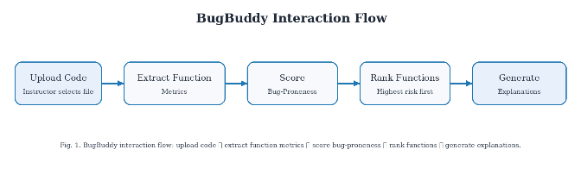
Fig. 1. BugBuddy dashboard interaction flow showing the instructor workflow: upload code, extract function metrics, score bug-proneness, visualize risk and complexity, rank functions, and generate explanations.

- Core BugBuddy Application Modules
Module | Purpose | Current Role in BugBuddy
Metric extraction | Compute function-level code features | Parses functions and prepares model inputs.
Model training | Learn mapping between metrics and labels | Trains Random Forest baseline and evaluation workflow.
Prediction engine | Score uploaded functions | Produces function-level risk estimates.
Explanation layer | Translates metrics into readable rationale | Supports instructor interpretation of flagged functions.
Web interface | Accepts uploads and displays results | Connects HCI workflow to model output.

Programming Language and Tools

The BugBuddy prototype is implemented in Python, with Flask used for the web application layer. Python was selected because it provides robust support for rapid prototyping, data analysis, machine learning, and static code analysis, making it a practical choice for an educational prototype that must combine data extraction, model training, and user interaction in a single environment.
The modeling workflow uses scikit-learn, specifically a RandomForestClassifier, to learn from labeled function-level metrics. This workflow matches standard supervised learning practice for software defect prediction and is consistent with the use of tree-based models in recent bug-prediction research [1].
The broader project documentation references Radon and Lizard for extracting complexity-oriented metrics from source code. These tools align with the goal of working at the function level and help derive variables such as lines of code, cyclomatic complexity, and related structural attributes that are commonly used in defect-prediction studies [1], [2]. The interface layer is implemented through Flask template rendering and client-side HTML/CSS, displaying tabular output and charts that include file name, function name, metrics, risk estimate, and explanation text. This supports a human-in-the-loop workflow in which the user remains the final decision maker [3].

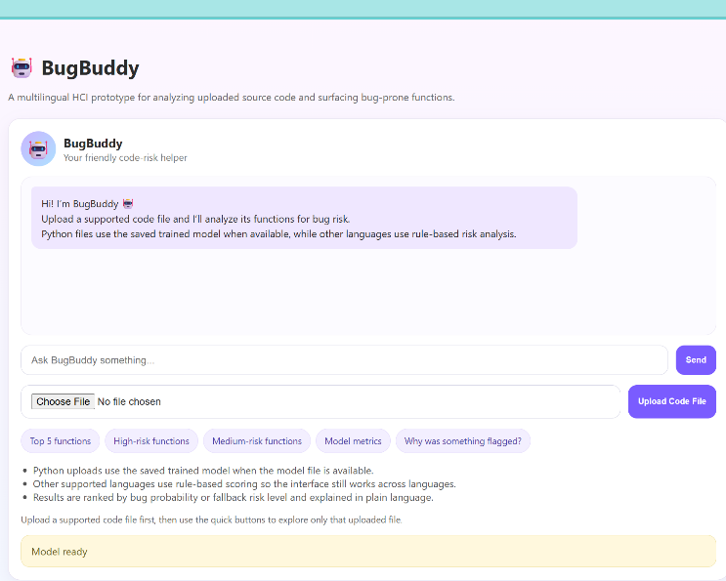
Fig. 2. Main BugBuddy home screen before file upload, showing the chatbot panel, upload controls, quick-action buttons, and model-ready status.

Algorithms and Equations

The main predictive algorithm in the current BugBuddy prototype is Random Forest classification. Random Forest is an ensemble technique that builds multiple decision trees and aggregates their outputs to improve robustness and reduce overfitting; tree-based approaches remain competitive in defect prediction because they can model nonlinear relationships between metrics and bug labels while still allowing feature-importance analysis [1].
For each function represented by a feature vector $x$, BugBuddy estimates the bug-proneness probability $P(\text{bug}∣x)$ and ranks functions in descending order of $P(\text{bug}∣x)$. This probability is visualized as risk scores on the dashboard, allowing instructors to quickly identify the highest-risk functions.
Cyclomatic complexity is a central variable in the project because it approximates the number of independent paths through a function and is commonly associated with defect risk and testing difficulty [1], [2]. It is defined as:

$$\text{CC}=E-N+2P$$

where $E$ is the number of edges in the control-flow graph, $N$ is the number of nodes, and $P$ is the number of connected components or exit points. Functions with higher complexity often require more careful inspection because they include more branching paths and decision points [1], [2].
The evaluation metrics used in BugBuddy include precision, recall, F1-score, and ROC-AUC, which are standard in defect-prediction research [1]. Precision is defined as:
$$\text{Precision}=\frac{TP}{TP+FP}$$
Recall is defined as:
$$\text{Recall}=\frac{TP}{TP+FN}$$
The F1-score is defined as:
$$\text{F1}=\frac{2⋅\text{Precision}⋅\text{Recall}}{\text{Precision}+\text{Recall}}$$
ROC-AUC summarizes the trade-off between true-positive and false-positive rates across thresholds and is visualized as the area under the ROC curve [1]. These measures are appropriate for BugBuddy because the educational problem is less about raw accuracy and more about prioritizing risky functions without overwhelming instructors with false alarms, which aligns with the dashboard's decision-support goal [3], [4].

System Design and Implementation

The implemented BugBuddy pipeline begins with a function-level metrics dataset. The Week 2 implementation used a Python extraction script to scan repositories, discover .py files, and compute metrics including function name, line numbers, length, cyclomatic complexity, and Radon outputs, producing a pilot dataset that served as the basis for labeling and model development.
In Week 3, the prototype added a model-training workflow. The training script loads data/pilot_metrics.csv, selects feature columns, validates the dataset, performs a stratified train-test split, trains a RandomForestClassifier, computes precision, recall, F1, and ROC-AUC, and saves both a metrics JSON file and a ROC image to the results folder. This step shows that the project achieved a real end-to-end machine-learning baseline.
The application phase connects the trained model to the BugBuddy web app. Uploaded Python files are parsed, transformed into the same function-level features used during training, and then scored by the model so the interface can present a ranked table of bug-prone functions, a ROC curve visualization for model performance, and a feature-importance bar chart showing which metrics drive the predictions [3], [5].
In the broader design, non-Python files are routed through a simpler rule-based analyzer, so the tool remains usable even when a learned model is unavailable for that language. From an HCI perspective, the key implementation feature is the explanation layer and its visual representation. Rather than showing only a probability score, BugBuddy also explains why a function is risky using metric-based language such as high complexity, above-average length, or elevated branching, and surfaces these explanations alongside the ranked results. This supports interpretability and aligns with visual analytics guidance for explainable AI, where visual summaries and textual explanations help users make sense of model behavior [5].

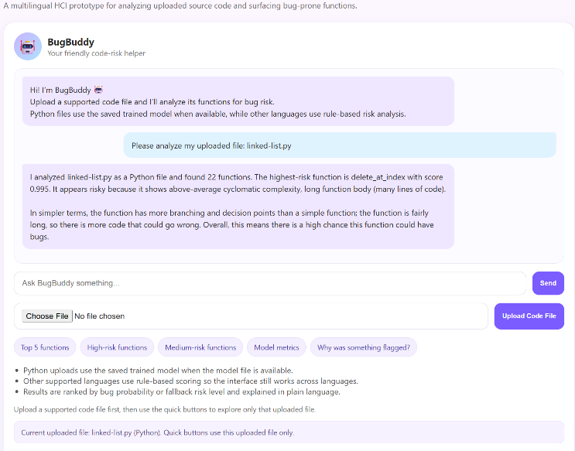
Fig. 3. Uploaded Python file with scored functions visible in the BugBuddy interface, illustrating model-based risk analysis and metric display for a Python submission.

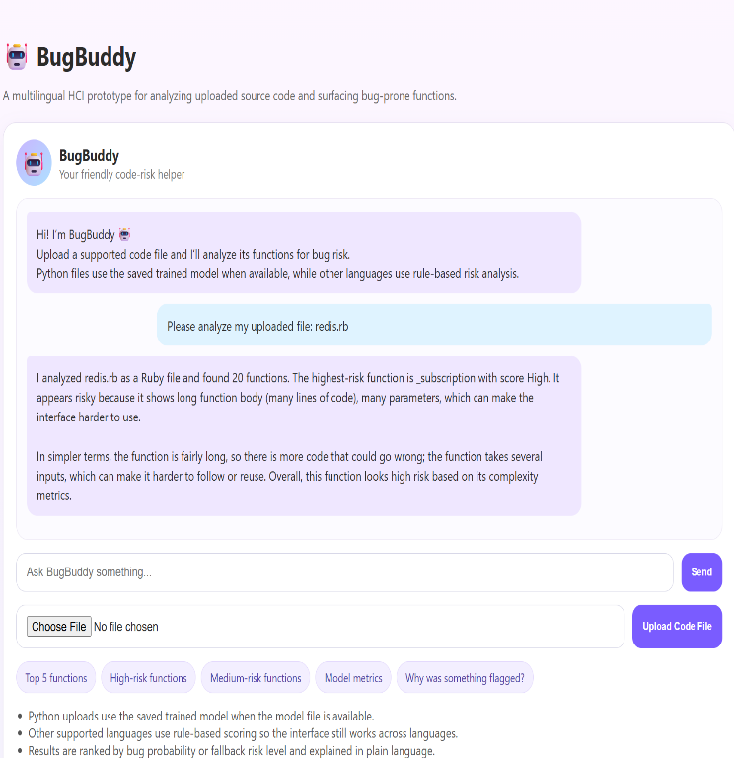
Fig. 4. Example of non-Python fallback scoring in BugBuddy, demonstrating multilingual support through rule-based risk analysis for an uploaded Ruby file.

Results
Project artifacts indicate that the prototype successfully transitions from metric extraction to model training, then to live prediction and visualization on uploaded files. The pilot workflow demonstrates feasibility by showing that function-level metrics can be extracted, transformed into model inputs, and returned to the interface as ranked review priorities.
At the same time, the results should be interpreted carefully. The visible Week 3 workflow uses a small, labeled subset and a limited feature configuration, while later project descriptions discuss a richer feature set and stronger pilot results. For that reason, the system should be described as prototype-level evidence rather than broad production-scale validation [1].

- Reported Pilot Random Forest Performance on the Labeled Function-Level Dataset
Metric | Value
ROC-AUC | 1.000
Precision | 1.000
Recall | 1.000
F1-score | 1.000

The project materials indicate that function length and lines of code were among the strongest predictors, followed by cyclomatic complexity and parameter count, which is consistent with the defect-prediction literature, which shows that larger and more structurally complex units are more likely to contain defects or require closer inspection [1], [2].

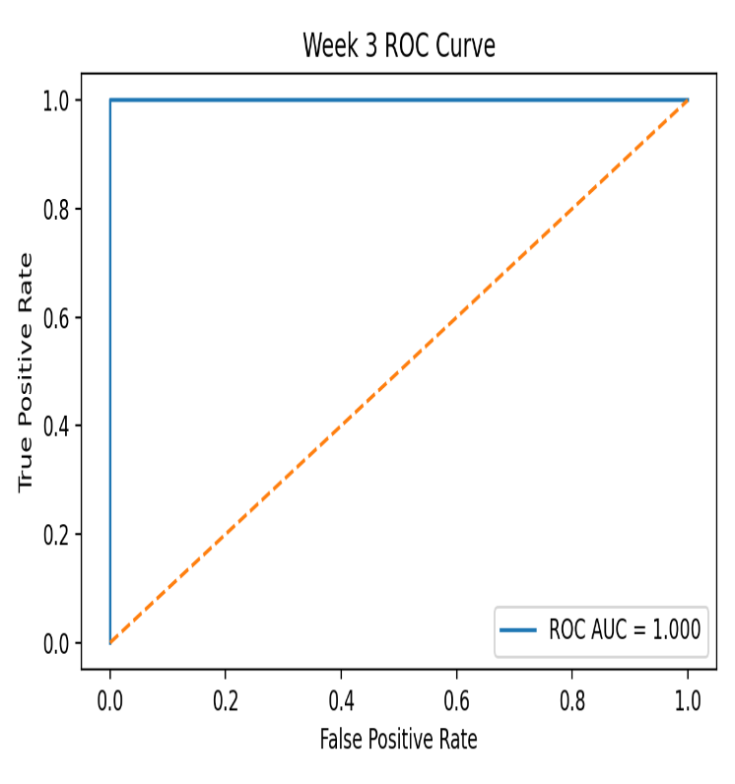
Fig. 5. ROC curve for the Week 3 Random Forest model, showing an ROC-AUC of 1.000 on the labeled pilot dataset.

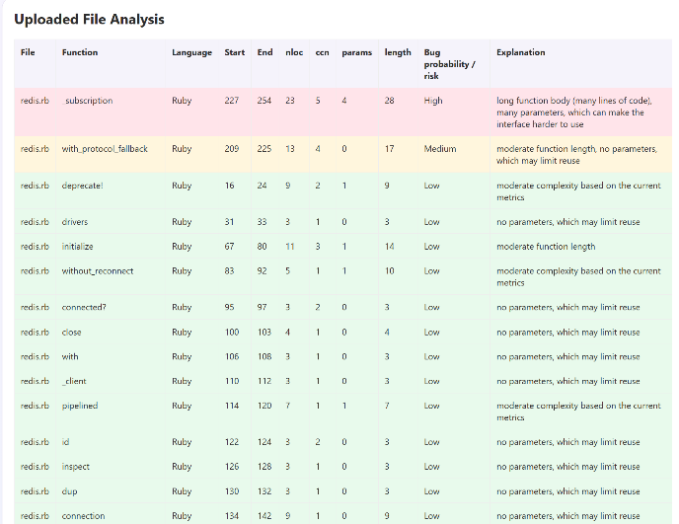
Fig. 6. Ranked BugBuddy results table with file names, bug-risk levels, color-coded or icon-based indicators, and plain-language explanations for flagged functions.

An application-level example involved analyzing a Python file containing multiple functions. BugBuddy identified one function as highest risk and explained the result based on high cyclomatic complexity and function length, while simpler functions were assigned much lower probabilities. This example illustrates the intended instructional value of the tool: it narrows review effort and provides a rationale that can be converted into classroom feedback.

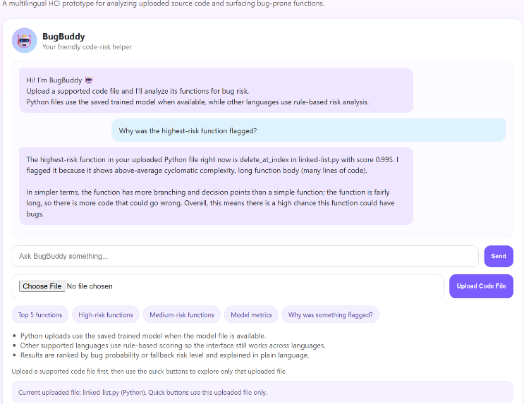
Fig. 7. Chatbot explanation showing why the highest-risk function was flagged, including metric-based rationale presented in plain language next to the visualization.

Discussion

BugBuddy aligns well with the goals of a human-computer interaction course project by combining predictive analytics with a user-facing dashboard designed for clarity and actionability [3], [4]. The system does not merely classify code; it visualizes the predictions and presents them in a way that supports decision-making. This is an important distinction in HCI because a technically accurate model can still be unusable if its outputs are opaque, poorly organized, or difficult to interpret [3], [5].
The current prototype demonstrates several strengths. It operates at the function level, which is a natural granularity for educational review [1], [2]. It uses interpretable features that can be described directly to the user and visualized in charts and tables. It also supports an explanation-oriented interaction model, which helps bridge the gap between machine-learning output and human judgment [5]. These characteristics make the application more suitable for classroom use than a purely backend-oriented defect predictor that lacks visualization or explanation.
However, the project also has limitations. The broader vision includes static, change, and behavioral metrics across student GitHub repositories, while the strongest implemented path currently relies on static metrics and a smaller pilot dataset [1]. The final version of the paper should remain synchronized with the actual submission artifacts to avoid overstating what is currently implemented.
Future work should extend the documented version of BugBuddy by incorporating commit-history mining, behavioral patterns, comparative model baselines, broader multi-language support, and more systematic user testing with instructors. These additions would move the project closer to the complete architecture described in the proposal and provide a stronger empirical basis for evaluating the HCI benefits of the dashboard and explanation interface [3]–[5].

Conclusion

This paper presented BugBuddy, a function-level bug-prediction dashboard for student code designed as a human-centered decision-support tool. The prototype combines Python-based metric extraction, Random Forest classification, and a Flask-style upload-and-explain interface with visualizations of metrics and risk scores to help instructors identify likely problem areas before beginning manual code review.
The strongest contribution of BugBuddy is not only that it predicts risk, but that it presents the prediction in an interpretable and usable way. By pairing ranked function-level outputs with metric-based explanations and simple visualizations, the application supports visibility, feedback, and instructor-centered decision-making [3], [5]. While the current implementation remains a prototype and should be presented honestly as such, it provides a strong foundation for further development toward richer metrics, deeper evaluation, and more robust HCI testing [1].

References
- S. Chowdhury, G. Uddin, H. Hemmati, and R. Holmes, “Method-Level Bug Prediction: Problems and Promises,” ACM Transactions on Software Engineering and Methodology, vol. 33, no. 4, pp. 1–31, 2024, doi: 10.1145/3640331.
- E. Giger, M. D’Ambros, M. Pinzger, and H. C. Gall, “Method-level bug prediction,” in Proceedings of the ACM-IEEE International Symposium on Empirical Software Engineering and Measurement, 2012, doi: 10.1145/2372251.2372285.
- A. M. Cook, B. Bach, and A. Quigley, “Data Quality, Mismatched Expectations, and Moving Requirements: The Challenges of User-Centred Dashboard Design,” in Proceedings of the 34th Australian Conference on Human-Computer Interaction, 2022.
- E. L. Rojas, M. P. Horton, S. M. Janke, and A. M. H. N. Tareq, “Developing instructor dashboards through human centered design,” International Journal of Educational Technology in Higher Education, 2024.
- G. Alicioglu and Y. Sun, “A survey of visual analytics for Explainable Artificial Intelligence methods,” Computers & Graphics, vol. 102, pp. 502–520, 2022.
- N. Lopez, “Predicting Bug-Prone Functions in Student Code via Web Upload Analysis,” course prototype and implementation materials, Full Sail University, 2026.

